SQ Process
Evaluierung: Thomas Nickel
1.1.1994-31.12.1999-31.12.2002-31.12.2005
Endtest 1.1.2006-31.12.2006

Start Generation (2 weeks)
1.1.94-31.12.99-31.12.2002
IS 5.5 years- OSS 3 years
Period: H1
Spread: 2
Slippage 0
Min Dist 5
Test Precision: Selected Timeframe
Date: EURUSD Asi Data

After Generation
Send all generated Strategies to retest
37981 Strategies

Filter Process
1.1.2003-31.12.2003
Filter 1
1: < Pf 1.3 raus
2: Ret/DD <1.0 raus

Period: H1
Spread: 2
Slippage 0
Min Dist 5
Test Precision: M1
Date: EURUSD Asi Data
29972 Strategies left

Filter 2
1.1.2004-31.12.2004
1: < Pf 1.3 raus
2: Ret/DD <1.0 raus

Period: H1
Spread: 2
Slippage 0
Min Dist 5
Test Precision: M1
Date: EURUSD Asi Data
27073 Strategies left

Filter 3
1.1.2005-31.12.2005
1: < Pf 1.3 raus
2: Ret/DD <1.0 raus

Period: H1
Spread: 2
Slippage 0
Min Dist 5
Test Precision: M1
Date: EURUSD Asi Data
19129 Strategies left

Filter 4
1.1.1994-31.12.2005 (complete Range)
1:2321 left
2:2063 left

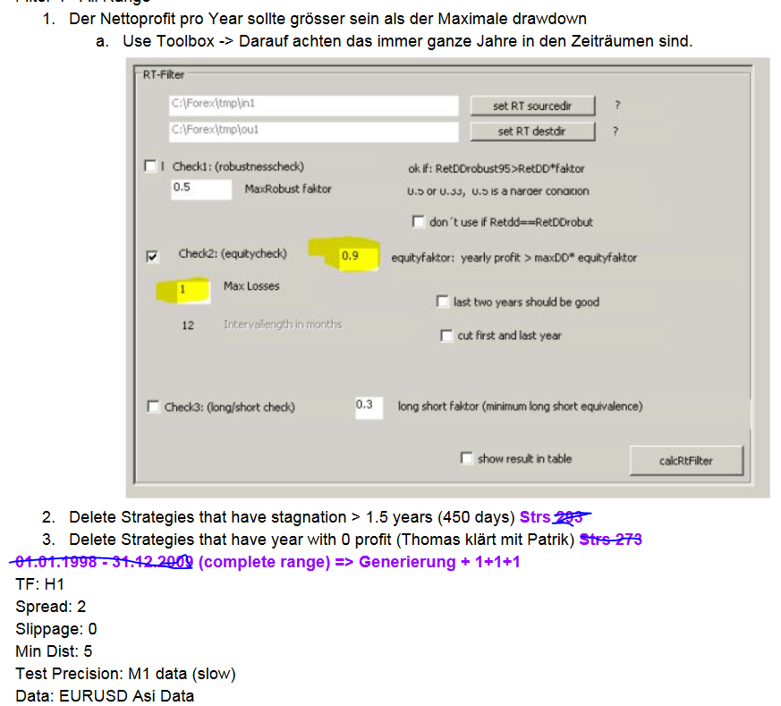

Filter 5
Test on different market GBPUSD
- pf 1.0 raus, 1910
- Stability <0.5 raus, 1471
Period: H1
Spread: 2
Slippage 0
Min Dist 5
Test Precision: M1
Date: GBPUSD Asi Data

Filter 6: Timeframe test I
- pf 1.0 raus, 1471
- Stability <0.5 raus, 1462
Period: M30
Spread: 2
Slippage 0
Min Dist 5
Test Precision: M1
Date: EURUSD Asi Data

Filter 7: Timeframe test II
- pf 1.0 raus, 1391
- Stability <0.5 raus, 1243
Period: H4
Spread: 2
Slippage 0
Min Dist 5
Test Precision: M1
Date: EURUSD Asi Data

Filter 8: Slippage Test
- pf 1.0 raus, 1243

Period: H1
Spread: 2
Slippage 5
Min Dist 5
Test Precision: M1
Date: EURUSD Asi Data

Filter 9:Montecarlo Analysis
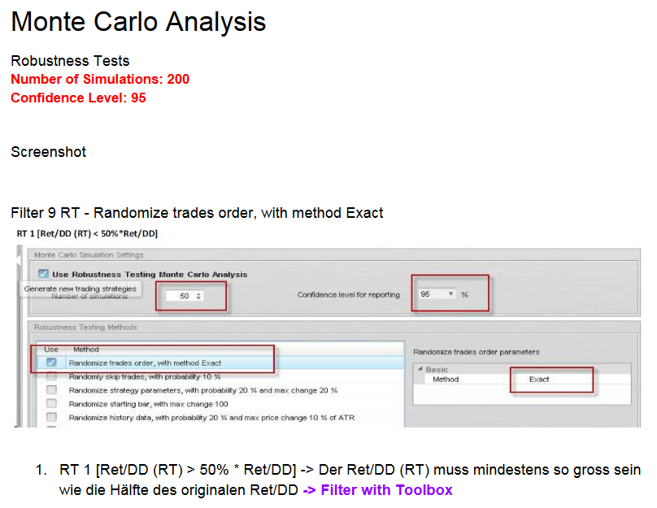
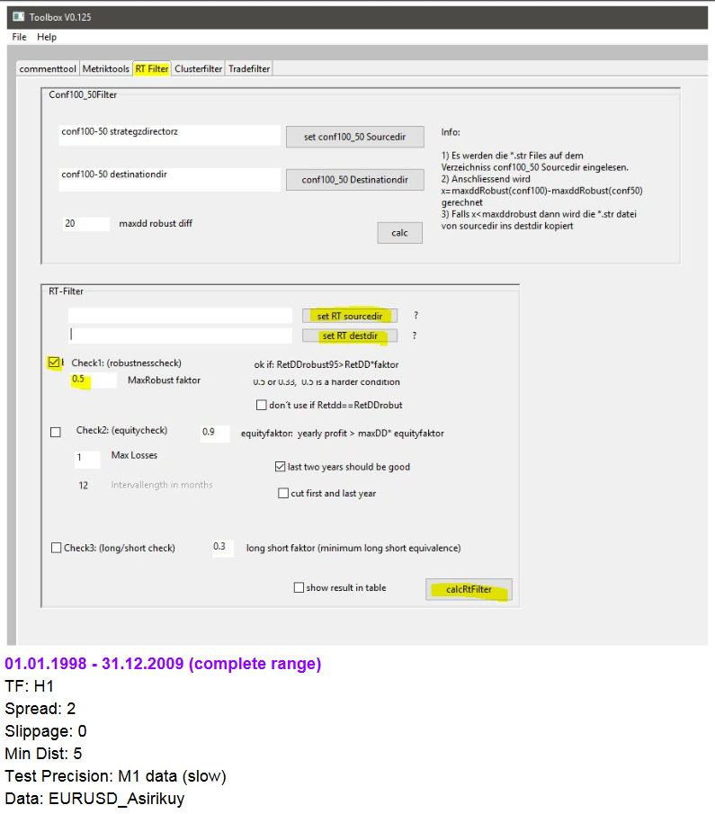
708 Strategies left
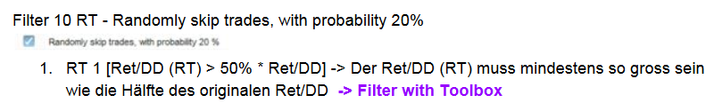
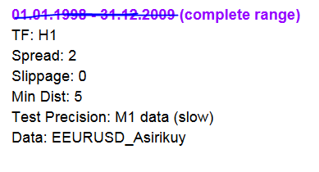

640 Strategies left

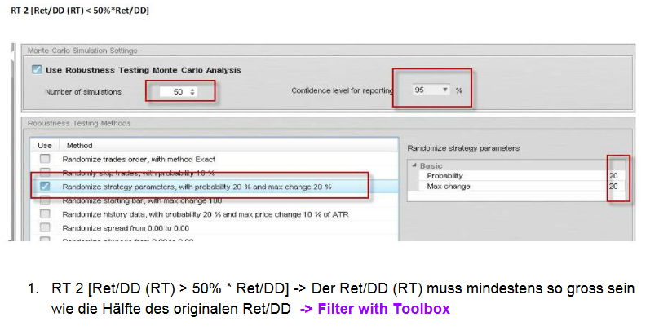

517 Strategies left

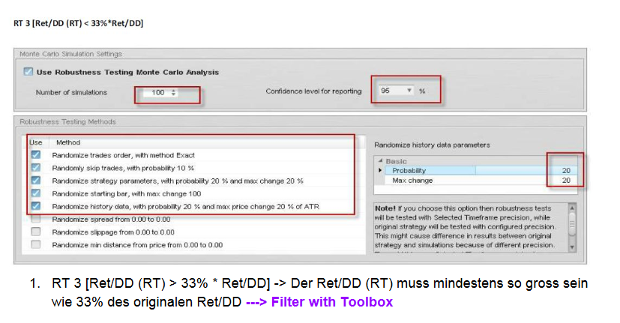
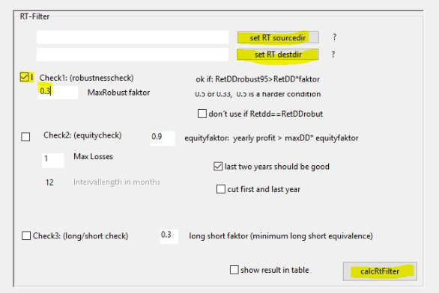
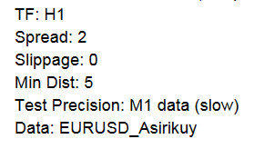
499 Strategies left

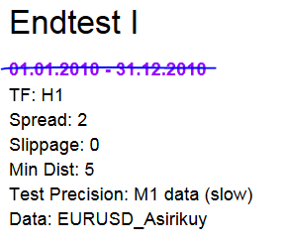
Endtest1: 1.1.2006-31.12.2006 (1year)

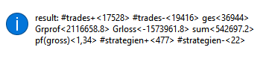
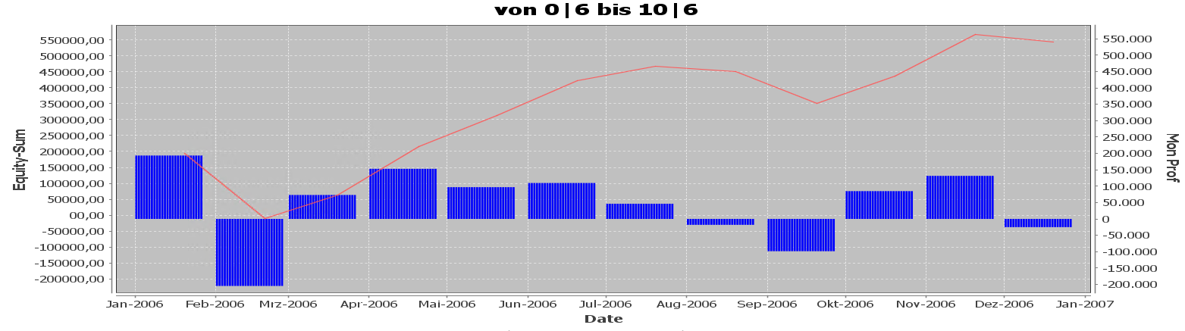

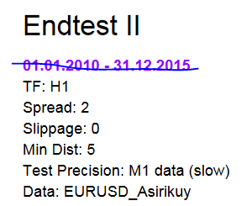
Endtest2: 1.1.2006-31.12.2010 (5 years)
